RECEIVING
- Remove the Bulk/Palatize page. The team will receive the bulk product from the BC client.
- Remove the Bin page. The team will always use the Production bin, which has been configured in BC.
- Add a page for the Expiration Date. SSM uses the Lot Number as the manufacturing date, but it should be a calculated value based on the item’s Expiration Date. The format of the lot should be LOCYYYYMMDD. The Location could come from the Location > Location Code field. For example, if the location code is TC, the item’s expiration calculation is 3Y, and the Expiration Date entered is 11/20/2028, the system should assign the lot number as TC20251120.
- Change the Quantity page to represent the quantity per pallet, not for the combination of all pallets. The total quantity should be the number of pallets times the quantity per pallet. The system is currently dividing values.
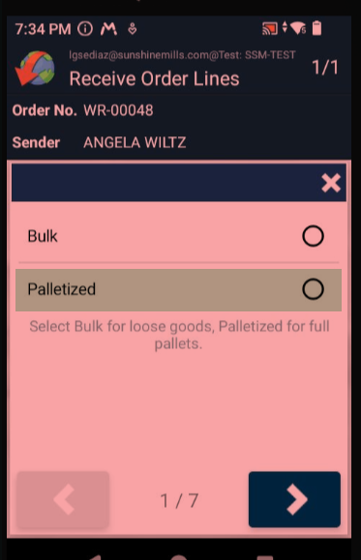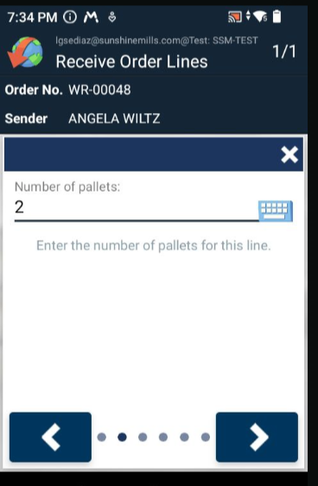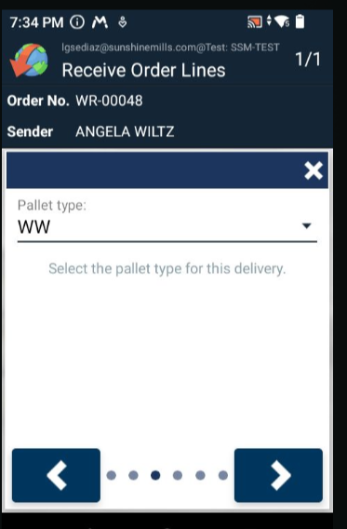
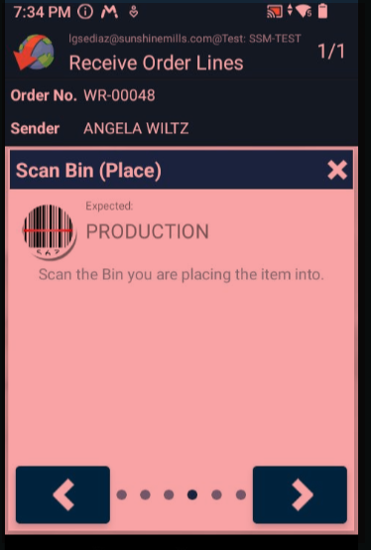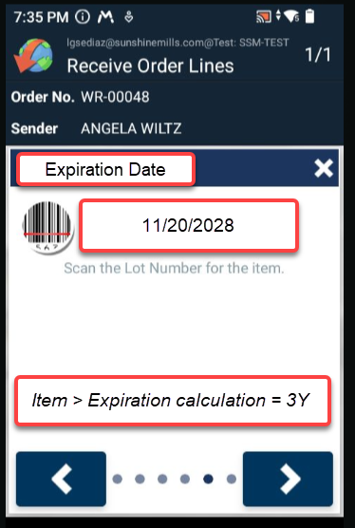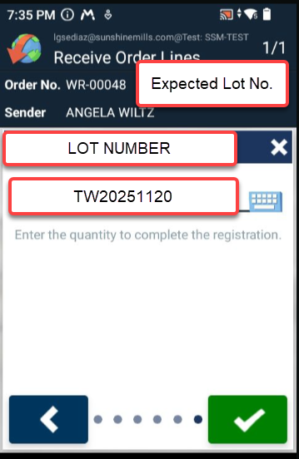
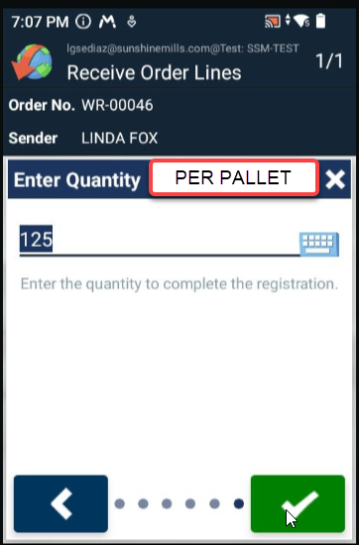

PICK
- Remove the Lot Number page.
